


2W Showroom
Technical Content
Copyright Schaeffler Technologies AG & Co. KG, 2024 – Alle Rechte vorbehalten. |



AGENDA

Efficient ICE Solutions (incl. Engine Control Units)
- Light Electric 2-Wheeler (incl. NX Inverter)

2 W P S H O W R O O M

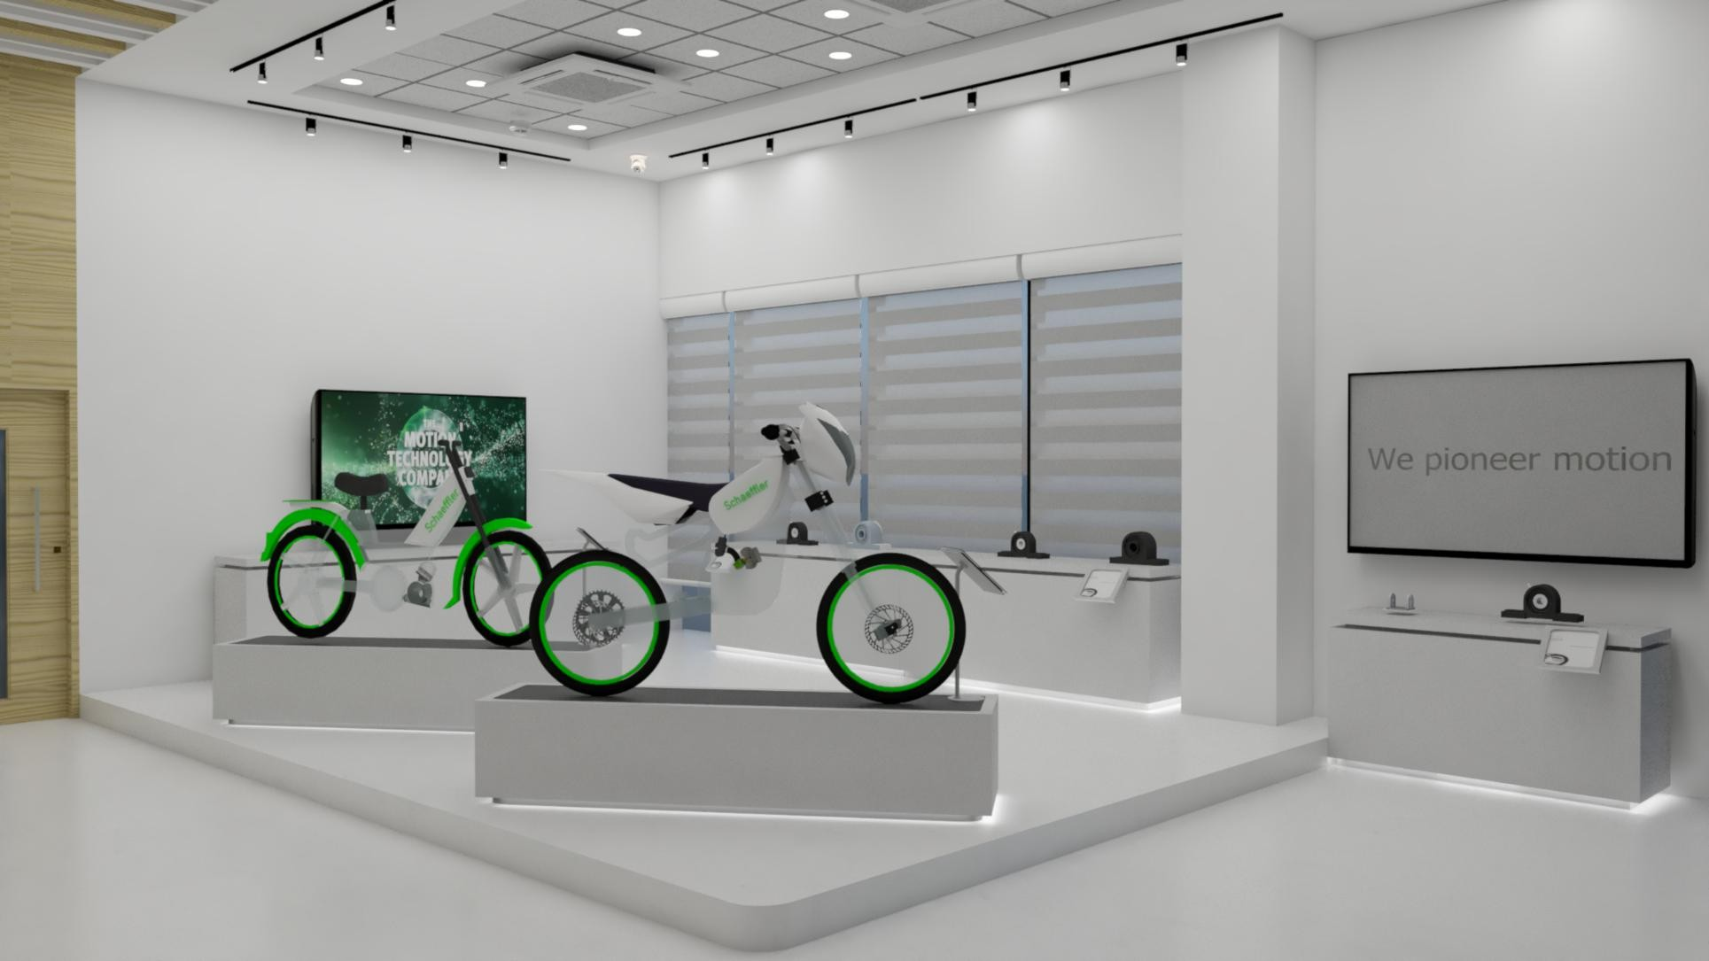
Concept Over view- Side View
4
2
6
7
1
3
EV
1
ICE
5



Physical model with Schaeffler 2WP
2
1

Interactive screen for AV presentations
3
Product display & Digital screen

Ceiling with light effects
4

Raised floor for all cabling work Digital CLAIM installation
5
6
7
Door installation



Exhibit Overview
Efficient ICE Solutions
Engine
Transmission & Chassis
Engine Control Units
- Fuel Injector
- Sensors
  - Knock sensor
  - Pressure sensor
  - Flex Fuel Sensor
- Hydraulic Chain tensioner
- Cam Roller
- BZ Pin
- One way clutch
- Bearings
  - Crankpin KZK
  - Pistonpin KBK
  - Drawn Cup Needle Roller Bearing (Starter Motor/Primary Drive Support) HK-RS Type
  - Cylindrical Roller with sheet metal cage
Transmission:
- Plastic cage and needle roller bearing (K Type)
- Machined Needle roller bearing RNA/NK
- Deep Groove Ball Bearings
Chassis:
- Drawn Cup Needle Roller Bearing (Swing arm application) HK/HNH Type
- Ball Bearing with ABS tonner
- Angular Contact Ball bearing
- Steering Head TRB
- M4A/M4B Twin Spark Mechatronic
- M4REK Mechatronic
- M4C Engine Control Unit


Exhibit Overview
Electrification

Mounted on the Skeleton Scooter:
- 48V e-Motor
- Control Unit electric Drive (eDCU)
- Inductive Rotor Position Sensor (iRPS)
- Battery Management System (BMS)



2 W S H O W R O O M

Efficient ICE Solutions – Engine

Products :
Objectives ENGINE:
Thanks to a consistent system approach, Schaeffler offers a large variety of sensors, actuators and bearings that play a significant role in terms of energy efficiency.
From Port Fuel Injectors, to knock sensors, bearings, our latest technologies guarantee a better efficiency for the 2-wheeler applications.
- Fuel Injector
  - Gasoline Deka 7
  - Gasoline Deka 10
- Sensors
  - Knock sensor
  - Pressure sensor
  - Flex Fuel Sensor
- Hydraulic Chain tensioner
- Cam Roller
- BZ Pin
- One way clutch
- Bearings
  - Crankpin KZK
  - Pistonpin KBK
  - Drawn Cup Needle Roller Bearing (Starter Motor/Primary Drive Support) HK-RS Type
  - Cylindrical Roller with sheet metal cage



Example
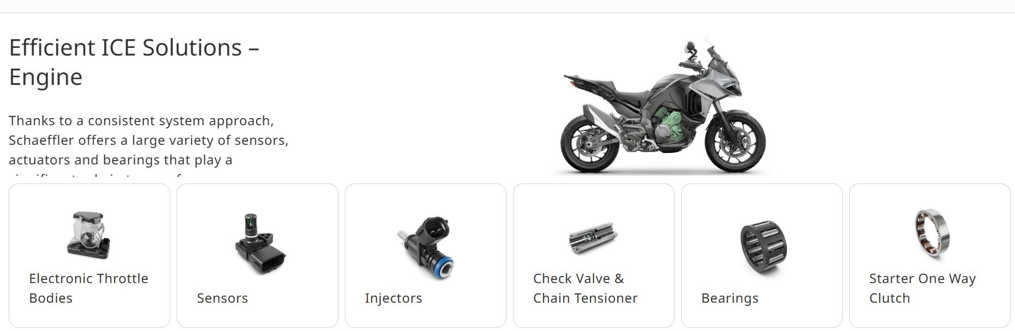


Features
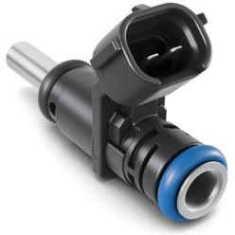


Gasoline Deka 7 Port Fuel Injector
Port Fuel Injection (PFI) injector with unique flexibility body, tip and spray configurations.
Plug-in Hybrid Electric Vehicle
Mild Hybrid Electric Vehicle
Gasoline

GENERATE MOTION
Highlights
Proven durability performance

Improved opening and closing performance

E-fuel compatible design
Advantages
- Fast opening / closing
- Various packaging options
- Flexible orifice configurations with various cone combination
- Low pulse width with high linear performance
- Low voltage sensitivity
System pressure | 2.5 to 6 bar
Static flow rate | Per application 0.75 g/s to 6.0 g/s
SMD size | 60 µm & higher (Qs < 3 g/s @ 400 kPa and Cone Spray)
Opening/Closing time | <1.1 ms ; <0.8 ms
Linearity Range/Pulse | 10:1 ; 1.2 – 1.3 ms (MOV = 5.5 V)
Typical spray pattern | Cone 10 °C – 30 °C, bent 5 °C- 25 °C  and split spray 15 °C – 30 °C (Combo)
Mounting | Intake manifold or cylinder head


Features
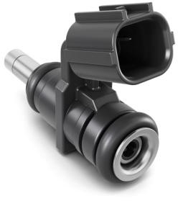


Gasoline Deka 10 Port Fuel Injector
The Gasoline Deka 10 Port Fuel Injector features high flow range and reduced packaging, also for twin and dual port engines and non- automotive applications.
Plug-in Hybrid Electric Vehicle
Mild Hybrid Electric Vehicle
Gasoline

GENERATE MOTION
Highlights
Compact design with high durability performance

Reduce leakage
and improve flow range

E-fuel compatible – Full stainless-steel design
Advantages
- Improved magnetics leading to faster closing time
- Improved tip leakage performance
- Designed for contamination robustness
- Low pulse width with high linear performance
- Smallest packaging offered
System pressure | 2.5 to 8 bar
Static flow rate | Per application 0.50 g/s to 8.0 g/s
SMD size | 60 µm & higher (Qs < 3 g/s @ 400 kPa and Cone Spray)
Opening/Closing time | <1.1 ms , <0.5 ms
Linearity Range/Pulse | 15:1 ; 1.1 – 1.2 ms (MOV = 5.5V)
Typical spray pattern | Cone 10 °C – 30 °C , bent 5 °C – 25  °C and split spray 15 °C – 30 °C (Combo)
Mounting | Intake manifold or cylinder head


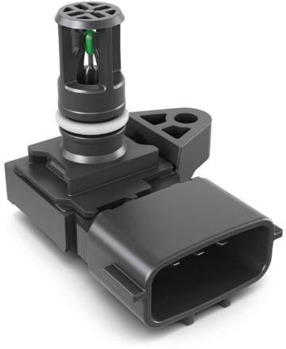



Pressure Sensor - Manifold Absolute with temperature sensor
Small and robust pressure sensor with integrated temperature sensing for manifolds.
Plug-in Hybrid Electric Vehicle
Mild Hybrid Electric Vehicle
Gasoline/Diesel
Highlights
Flexible transfer function calibration with programmable clip levels and OBD functionality

High accuracy and
temperature stability

Different housing/cover materials and protection gels to cope with toughest environments
Advantages
- Flexible calibration of transfer functions
- High accuracy
- Low-cost design and high quality
- Fulfills toughest EMC requirements
- Flexible housing, connector and mounting design
Features
- Pressure range: 7 kPa up to 500 kPa
- Accuracy: 1 % full scale (10 °C up to 85 °C)
- Temp. range: -40 °C up to 140 °C
- Output signal: Analog or SENT


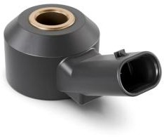


Knock Sensor – M8 Standard Design
Measures structural vibrations in the combustion engine to continuously adjust ignition parameters.
Plug-in Hybrid Electric Vehicle
Mild Hybrid
Electric Vehicle
Gasoline/Diesel

CONTROL MOTION
Highlights
Worldwide market leader with series manufacturing since 1990
>15 cable and integrated connector versions in production
Enabler for emission reduction as part of a modern ICE
Advantages
- Production locations in Americas, Europe, India and China
- Optimized ignition timing for maximum efficiency
- High sensitivity
- Compact design, nested bolt possible
- Increases engine power
- Decreases fuel consumption
- Nut and glued types with in-house engine qualification capability
Features
- Acceleration sensor based on piezo ceramic technology
- Frequency range: 3 kHz up to 25 kHz
- Possible integration of discharge resistor
- Integrated connector or cable version
- Various connector designs
- Nut and glue types assembly technology


Features
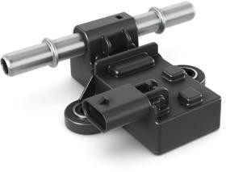
Flex Fuel Sensor
Detects ethanol concentration in gasoline / ethanol fuel mixture before engine injection.
Plug-in Hybrid Electric Vehicle
Mild Hybrid E e
lectric Vehicl
Gasoline/Diesel

CONTROL MOTION
Highlights
Enabler for emission reduction as part of a modern ICE
High accuracy with active temperature and conductivity compensation
Frequent signal output of
% ethanol and temperature
Advantages
- Worldwide market leader with series manufacturing since 1998
- Highly accurate prediction of ethanol concentration
- Enables ethanol detection before inject./combustion with OBD1 functionality
- Outputs ethanol concentration and fuel temperature within 250 ms after start-up
- Self-diagnostic capability
- Calibrations available for worldwide market
Measurement principle | Capacitive (0-100 % ethanol content)
Accuracy | ±5 % ethanol concentration
Pressure range | <10 bar (145 psi)
Fuel temp. range | -40 °C up to 80 °C
Environmental temp. | -40 °C up to 140 °C


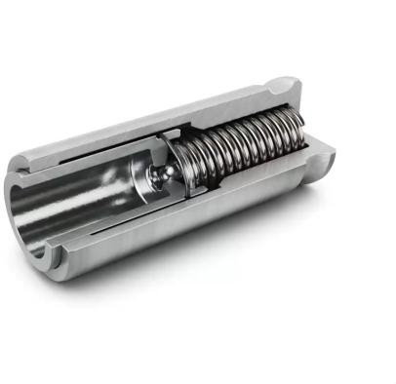


Hydraulic Chain Tensioner
Saving fuel is of highest importance, especially for motorcycles in the mass market. The hydraulic “eco” chain tensioner is a cost-effective solution for timing drives, reducing friction and fuel consumption while improving NVH behavior at the same time.

Gasoline/Diesel

GENERATE MOTION
Highlights

Outstanding NVH behavior

Reduced fuel consumption

Robust and cost-effective design
Advantages
- Chain blade design can be simplified
- Superior load peak compensation to that of mechanical tensioners
Features
- Steel piston in a formed steel housing
- Low chain pre-tensioning is possible
- Stable and precise damping behavior
- Reduced friction in the timing drive


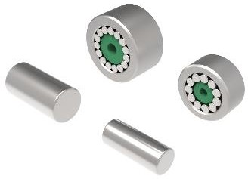
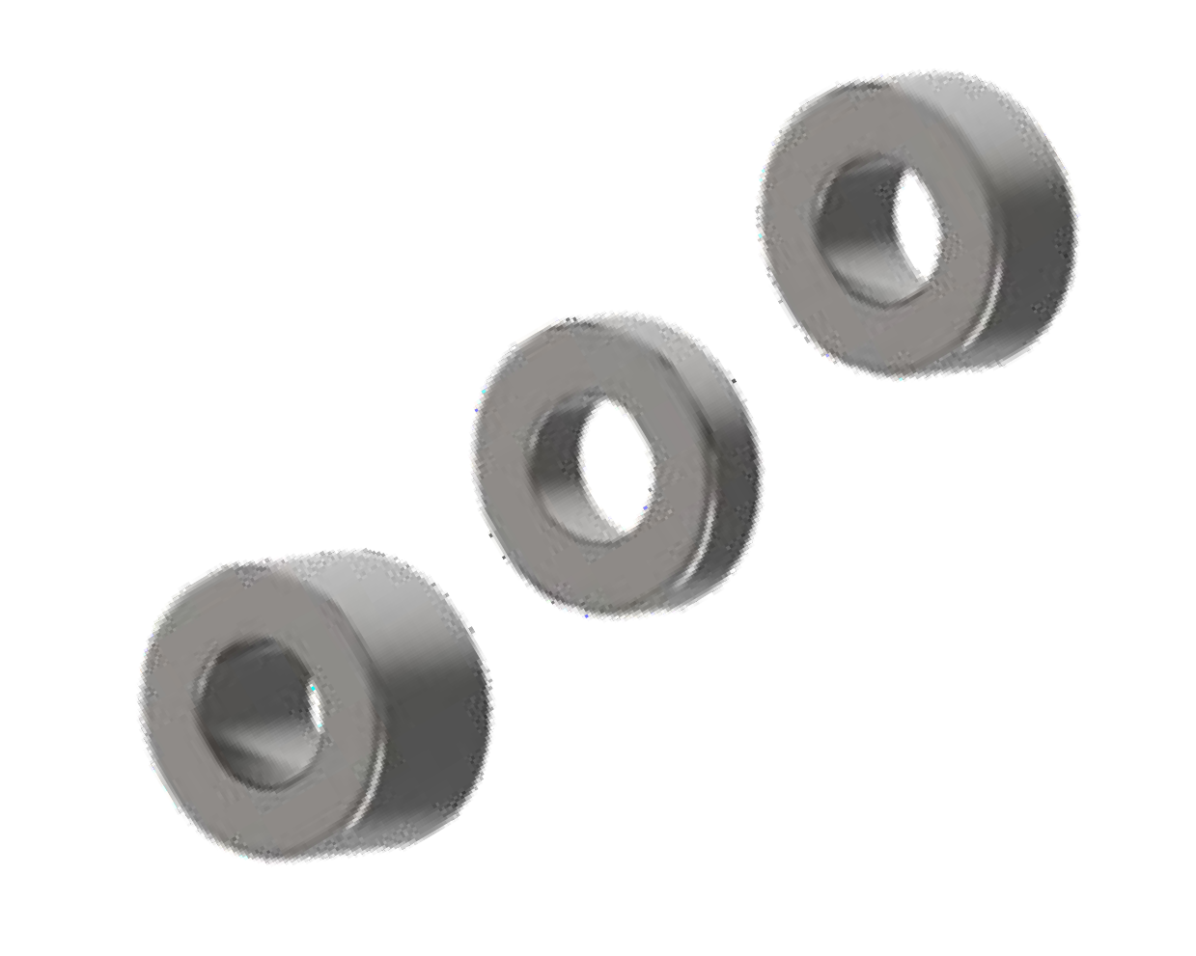

Cam roller and BZ Pin
Schaeffler has developed a wide range of outer rings, needles and Pin for various motorcycle applications. Currently we are supplying the cam roller and pin to India 2W customer for more than a decade.

Gasoline/Diesel

GENERATE MOTION
Highlights
Easy to assembly with rocker arm

Optimized friction

Suitable for engine speed up to 12000 RPM
Advantages
- Simplified, more cost-effective manufacturing process for the outer ring, needles and pins.
- High level of friction benefits against plain bearing
- Locally developed outer rings and pins; Cost-effective solution
Features
- Application specific design features on the product/drawing
- Needles sorts are defined as per bearing clearance requirements
- Automated production or assembly lines for cam roller; no manual interventions


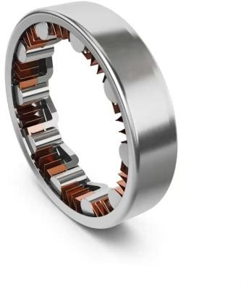

Starter One Way Clutch
This roller clutch for electric starter drives in motorcycles is manufactured using forming methods. It features a sophisticated design with reduced space requirements, increased performance and provides protection against failure. With its integrated torque limitation feature, it offers additional overload protection contributing to higher reliability. It is a cost-effective, high-quality solution reflecting an excellent price-performance ratio.
Gasoline/Diesel

GENERATE MOTION
Highlights

Easy to mount

Low space requirements and reduced weight

Suitable for high power densities
Advantages
- Simplified, more cost-effective manufacturing process for the magnet housing; hardening and grinding are no longer required
- High level of protection against failure and protection of the adjacent parts without additional components
- Cost-effective
Features
- Deep-drawn outer ring, manufactured using forming methods
- Integrated torque limitation function
- Schaeffler’s manufacturing technology ensures reliable
quality


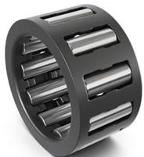
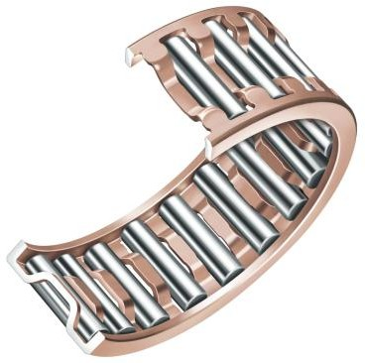

Crankpin KZK (Connecting rod big end bearing) Pistonpin KBK (Connecting rod small end bearing)
Crankpin needle bearings are the “heart” of each small combustion engine. Thanks to Schaeffler’ s proven know-how and quality standard, a long lifetime is guaranteed.

Gasoline/Diesel

GUIDE MOTION
Highlights
High resistance against centrifugal forces

Improved lubrication access

Easy assembly
Advantages
- Supports high centrifugal and acceleration forces and are suitable for high speeds.
- High wear resistance with improved cage surface quality
- Both inner and outer needle retention
- Long bearing lifetime
- Supports high frequency oscillating loads
- Good wear resistance during dry lubrication environment when cages are coated
- Improved cage surface quality
Features
- Different cage profiles according to application requirements available
- Various dimensions available
- Dedicated designs and dimensions on request
- Different coatings accordingly to application requirement and surrounding conditions ,


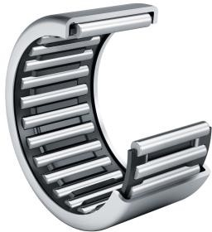
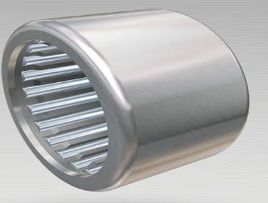

Drawn Cup Needle Roller Bearing
Applicable for transmission gear box, starter motor bearing, Primary drive support bearing, suspension application and linkage support application.
The drawn cup needle roller bearing benefits from our extensive experience in deep drawing technology to provide significant advantages with respect to cost and precision.

Gasoline/Diesel

TRANSMIT MOTION
Highlights
High load rating capacity Weight saving potential
by substitution of larger
bearings

Cost-efficient bearing by use of deep drawing technology
Advantages
- High load rating capacity with significantly more compact
design space than for a ball bearing
- High robustness against overload due to line contact
- Low radial installation space
- Bearings with needle roller and cage assemblies allow higher speeds. (Bearings with cage)
- offer extremely high load carrying capacity (Full complement bearing, without cage).
- Anti rust performance with grease version
Features
- Deep drawing technology for roller bearing outer ring
- Applicable for multiple applications
- Low noise and friction level
- Ease of assembly
- Cost effective solution


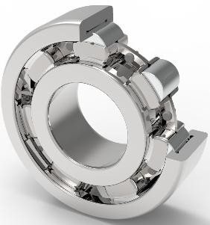

Cylindrical roller bearing with riveted steel cage
Schaeffler’s angular contact ball bearing with a special grease for
highest resilience of the steering head bearings.
Battery Electric Vehicle
Plug-in Hybrid Electric Vehicle
Mild Hybrid Electric Vehicle
Gasoline/Diesel

GUIDE MOTION
Highlights

Non Separable one unit easy to mount.

Higher Stiffness Controlled rolling elements both rings lips on either side
Advantages
- Higher power density in a small or the same envelope size
- High reliability compared to Ball bearings.
- Lower friction compared to standard CRB.
- Ease of assembly.
Features
- Non-separable self-retaining bearing.
- Reduction in frictional torque compared to standard CRB.
- Higher load rating compared to a Ball bearing in the same envelope size.
- Suitable for Higher radial & axial loads.
- Optimized/Lower number of rollers.
- Both sides lip for the Inner ring and outer rings.
- Riveted steel cage design.



E I C M A 2 0 2 5

Efficient ICE Solutions - Transmission

Products:
Objectives TRANSMISSION:
A robust and compact drivetrain is crucial in order to get the power of the engine to the wheel. This also requires reliable main shaft bearings in the transmission like ball bearings with centrifugal disc or roller bearings with special raceway profiles. Constant mesh needle bearings can help to downsize the oil supply.
Schaeffler X-Life tapered roller bearings help to decrease drivetrain friction
significantly.
The Modular Clutch Actuator is a key component for assisted shifting for comfortable motorcycle riding.
- Plastic cage and needle roller bearing (K Type)
- Machined Needle roller bearing RNA/NK
- Deep Groove Ball Bearings


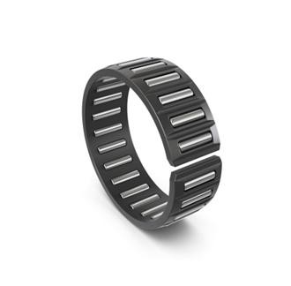
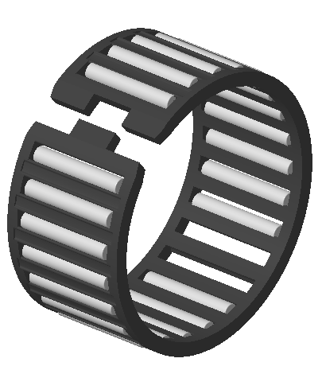


Plastic cage and needle roller assembly for Transmission Constant Mesh gear support.
Needle cages – open (Split type) or closed – are a cost efficient and compact solution as constant mesh bearing in gearboxes. They guarantee a reliable operation even under poor lubrication conditions. Therefore, they can help to minimize of the oil pump capacity and amount of oil required in the transmission.

Gasoline/ Diesel

TRANSMIT MOTION
Highlights
Easy assembly with open cage design

Compact dimensions

Robust solution
Advantages
- Low installation space required
- High load capacity
- High resistance to false brinelling
- Less friction, noise and heat
- Precise control on radial clearance
Features
- Inner and outer needle retention
- Various cage designs and materials available
- Special needle guidance for precise cage movement
- Improved shifting comfort
- Good dry –running characteristics


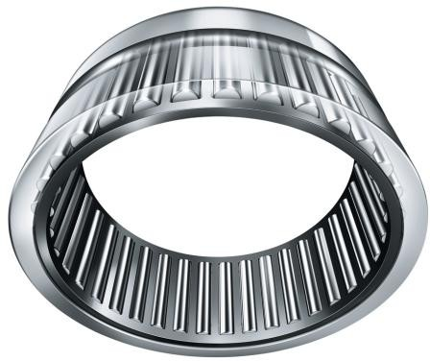


Machined needle roller assembly for Transmission support application

Applicable for transmission gear box application.
The machined outer ring benefits for high static load capacity to provide significant advantages with respect to cost and precision within low installation space. Special XL life bearing has special raceway profile to have enhanced bearing life.
Gasoline/ Diesel

TRANSMIT MOTION
Highlights
Easy assembly with open cage design

Compact dimensions

Robust solution
Advantages
- Low installation space required
- High load capacity (Very High Static Load Capacity)
- Less friction, noise and heat
- Precise control on radial clearance
- Increased rating life
- Best suited for applications having high static loads
Features
- Enhanced life & durability for Transmission Application
- Ease of assembly
- Cost optimized solution


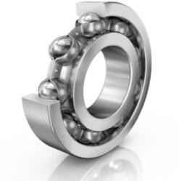

Ball bearing for Engine & Gearbox
Schaeffler’s angular contact ball bearing with a special grease for
highest resilience of the steering head bearings.
Battery Electric Vehicle
Plug-in Hybrid Electric Vehicle
Mild Hybrid Electric Vehicle
Gasoline/Diesel

GUIDE MOTION
Highlights

Higher lifetime special heat treatment.

Higher Mileage Reduced friction
Advantages
- Reduced friction
- Higher load rating
- Reduced fuel consumption
- Higher bearing lifetime
- Higher resistance against contamination.
Features
- Versatile, self-retaining
- Simple design, robust in operation and easy to maintain.
- Support radial & axial forces in both directions
- Low noise and low friction
- Special coating & heat treatment.



E I C M A 2 0 2 5

Efficient ICE Solutions - Chassis

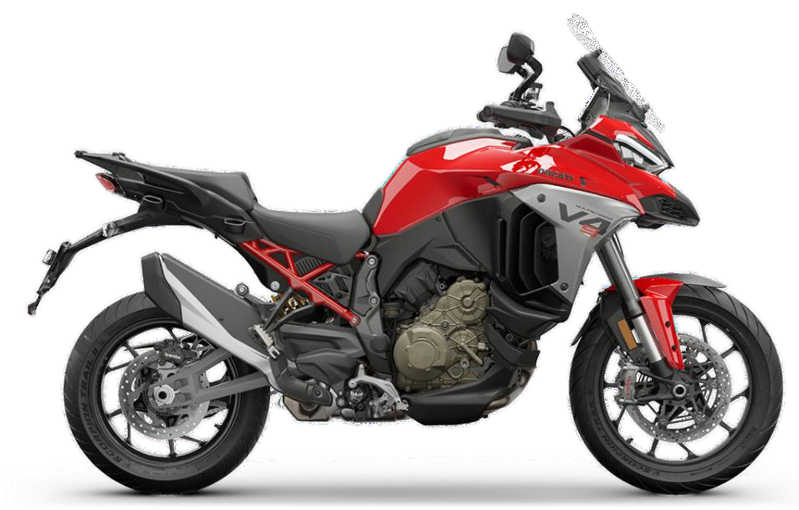
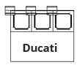
Products:
Objectives CHASSIS:
Chassis bearings directly impact the riding feeling and vehicle behavior. This comprises the steering head bearing for a smooth steering feeling as well as radial spherical bearings in the steering damper for a stable dynamic behavior. Schaeffler also offers special needle swing bearings for highest load capacities like our HNH type as well as a special wheel bearing with integrated cassette seal and ABS encoder.
- Drawn Cup Needle Roller Bearing (Swing arm application)
HK/HNH Type
- Ball Bearing with ABS tonner
  - Wheel bearing with encoder sealing
  - Wheel bearing friction reduction (ELS)
- Angular Contact Ball bearing
- Steering Head TRB





Drawn Cup Needle Roller Bearing
Applicable for transmission gear box, starter motor bearing, Primary drive support bearing, suspension application and linkage support application.
The drawn cup needle roller bearing benefits from our extensive experience in deep drawing technology to provide significant advantages with respect to cost and precision.

Gasoline/Diesel

TRANSMIT MOTION
Highlights
High load rating capacity Weight saving potential
by substitution of larger
bearings

Cost-efficient bearing by use of deep drawing technology
Advantages
- High load rating capacity with significantly more compact
design space than for a ball bearing
- High robustness against overload due to line contact
- Low radial installation space
- Bearings with needle roller and cage assemblies allow higher speeds. (Bearings with cage)
- offer extremely high load carrying capacity (Full complement bearing, without cage).
- Anti rust performance with grease version
Features
- Deep drawing technology for roller bearing outer ring
- Applicable for multiple applications
- Low noise and friction level
- Ease of assembly
- Cost effective solution


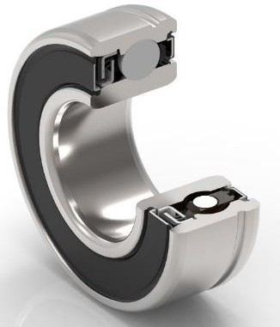

Wheel bearing with encoder sealing
Schaeffler’s angular contact ball bearing with a special grease for
highest resilience of the steering head bearings.
Battery Electric Vehicle
Plug-in Hybrid Electric Vehicle
Mild Hybrid Electric Vehicle
Gasoline/Diesel

GUIDE MOTION
Highlights

Go Digital embedded with encoder for ABS.

Higher Accuracy Controlled Braking more accurate speed measurement.
Advantages
- Encoder integrated into sealing.
- Excellent functional feasibility and predictability.
- Compatible with different sensing technologies (Hall, magneto-resistive).
- Fewer parts & installation space on the system level.
- No additional encoder assembly required.
- Reliable over lifetime & better protection against dirt/dust.
- Robust and proven technology from Automotive.
Features
- Encoder integrated into sealing.
- Excellent functional feasibility and predictability.
- Compatible with different sensing technologies (Hall, magneto-resistive).
- Robust and proven technology from Automotive.


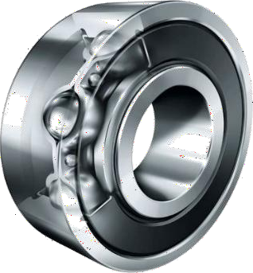

Wheel bearing friction reduction (ELS)
Schaeffler’s angular contact ball bearing with a special grease for
highest resilience of the steering head bearings.
Battery Electric Vehicle
Plug-in Hybrid Electric Vehicle
Mild Hybrid Electric Vehicle
Gasoline/Diesel

GUIDE MOTION
Highlights

Higher lifetime new effective sealing design.

Higher Mileage Reduced friction
Advantages
- Reduced friction
- Better sealing performance
- Reduced fuel consumption
- Higher bearing lifetime
Features
- Extra low-friction seal (ELS) with special geometry
- Optimized internal geometry and cage design
- Premium raceway and ball quality


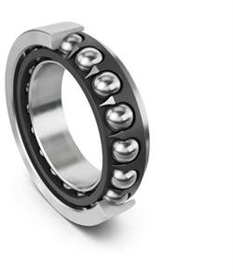

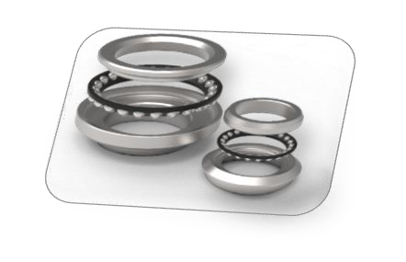
Steering Head Angular Contact Ball Bearing
Schaeffler’s angular contact ball bearing with a special grease for
highest resilience of the steering head bearings.
Battery Electric Vehicle
Plug-in Hybrid Electric Vehicle
Mild Hybrid Electric Vehicle
Gasoline/Diesel

GUIDE MOTION
Highlights
Outstanding steering feeling due to high precision balls and raceways

Highest resilience absorbs more shocks
Advantages
- Higher rating and operating life.
- Increased reliability.
- Low noise.
- Lower friction.
- Reduced steering efforts.
- Reduced heat generation.
- Extended maintenance intervals.
- Reduced overall operating costs.
- Better aesthetic.
Features
- Optimized internal construction.
- Improved raceway surfaces.
- Improved ball quality.
- Controlled running tolerances.
- 45°contact angle.
- Higher thrust capacity.
- Higher load rating and service life
- Increased reliability.
- Downsizing/Weight reduction.
- Higher power density.
- Data Matric Code (DMC)


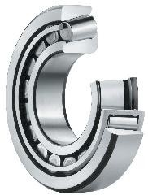

Steering Head Taper roller Bearing
Schaeffler’s angular contact ball bearing with a special grease for
highest resilience of the steering head bearings.
Battery Electric Vehicle
Plug-in Hybrid Electric Vehicle
Mild Hybrid Electric Vehicle
Gasoline/Diesel

GUIDE MOTION
Highlights

Higher jumps on Off-road Drive, Higher load rating

Highest resilience absorbs more shocks
Advantages
- Higher rating and operating life.
- Increased reliability.
- Low noise.
- Lower friction.
- Reduced steering efforts.
- Reduced heat generation.
- Extended maintenance intervals.
- Reduced overall operating costs.
- Better aesthetic.
Features
- Optimized internal construction.
- Improved raceway surfaces.
- Controlled running tolerances.
- Higher thrust capacity.
- Higher load rating and service life
- Increased reliability.
- Higher power density.
- Data Matric Code (DMC)

- Dampen high shocks



E I C M A 2 0 2 5

Engine Control Units

Products:
Objectives Engine Control Units:
Schaeffler has a strong and demonstrated expertise in the development of Electronic Control Units – addressing every kind of 2-wheeler & Powersports application. Whereas the 4th ECU generation has been successfully introduced over the past decade, a new smarter generation is about to emerge – equipped with cybersecurity, FOTA (Firmware Over-The-Air) automatic transmission management, and master control units’ functionalities. With these technologies, The Motion Technology Company ensures more efficiency, safety and drivability when keeping the riding pleasure.
- M4A/B Twin Spark Mechatronic

- M4REK Mechatronic

- M4C Engine Control Unit


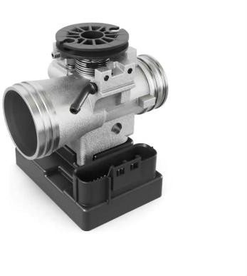


M4A/B Single/Twin Spark Mechatronic
For single cylinder, 4 stroke engines from 50 cc up to 350 cc in light motorcycles and scooters.

Gasoline

GENERATE MOTION
Highlights
Single cylinder, Single/twin sparks solution

Very compact size and easy mounting

Throttle body size from ø16 up to 34 mm
Advantages
- ECU with integrated throttle body, sensors and actuator
- Uses Schaeffler automotive electronics and technologies
- Ethanol compatible
- Several configurations: Engine mounting interface, throttle size, cable interface
- Integrated 3-axis accelerometer (Tilt sensor)
Features
- Single pocket 24/34 pins connector (equivalent to a 38/43 pins standalone ECU)
- IPX6 and IPX9K (high pressure cleaning)
- Operating temperature range: -30 °C up to +85 °C
- 32 bit microcontroller, 32 MHz, 768 Kb Flash
- CAN interface
- EURO5 OBDII stage 2 compliant


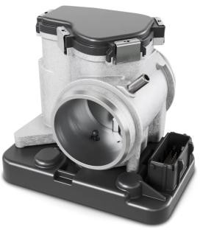


M4REK Mechatronic
To manage airflow with embedded ECU. For single-cylinder, 4-stroke engines from 250 cc up to 500 cc for middle-range motorcycles, scooters and ATV, including support for Ride-by-Wire technology.
Plug-in Hybrid Electric Vehicle
Mild Hybrid Electric Vehicle
Gasoline

GENERATE MOTION
Highlights
Engine Control Unit with integrated Electronic Throttle Control and sensors

Very compact size

Easy mounting
Advantages
- Uses Schaeffler automotive electronics
- Several configurations: Engine mounting interface, throttle diameter
- Throttle body size from ø 28 mm up to 42 mm
Features
- Single pocket 36 pins connector (equivalent to a 47 pins standalone ECU)
- IPX6 and IPX9K (high pressure cleaning)
- Operating temperature range: -30°C up to +85°C
- 32 bit microcontroller, 80 MHz, 1.5 Mb Flash Memory
- CAN interface
- EURO5 OBDII stage 2 compliant
- Separate safety monitoring unit for ETC system (ISO-26262 compliant)


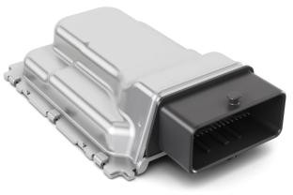

M4C Engine Control Unit
The M4C Standalone Ride-by-Wire Engine Control Unit is designed for 1- and 2-cylinder, 2- and 4-stroke engines operating up to 16,000 rpm, and is ideal for mid- to high-end motorcycles, scooters, and ATVs.
Plug-in Hybrid Electric Vehicle
Mild Hybrid Electric Vehicle
Gasoline

GENERATE MOTION
Highlights
Small and compact design for both 2 and 4 strokes engines either MTB or ETB

Knock sensor
compatible (x2)

Use automotive technology
Advantages
- Controls up to two electric throttle bodies or a mechanical throttle body and a stepper
- Operates up to two injectors per cylinder
- Euro 5 with OBD-II compliance
- ISO-26262 ready / Asil B
Features
- 32 bit microcontroller, 80 MHz
- 1.5 MB Flash Memory
- IP67 and IP6K9K (high pressure cleaning)
- Separate safety monitoring unit for ETC system
- 4 binary O2-sensors (opt. 1 linear + 1 binary O2-sensors)
- CAN (opt. LIN interface)
- Single pocket 64 pins connector



3 Electrification – Skeleton Scooter
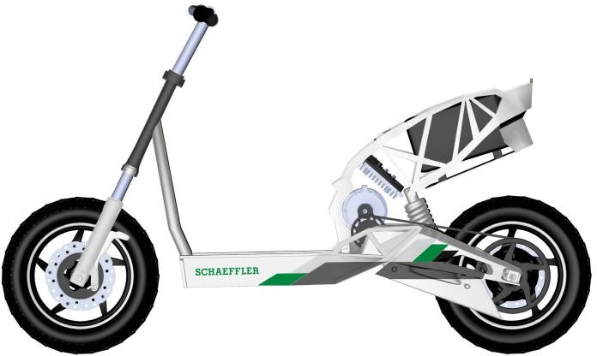
Objectives:
Integrated, compact and cost-effective 2-wheeler dedicated system solution for full electric drive transition of light 2-wheeler high volume market in Asia. The 48-volt powertrain system is designed for a performance range of 3 to 7 kW, the electrified equivalent of 2-wheelers up to 150 cc. The eDCU (electric Drive Control Unit), which combines vehicle control and inverter functions in one unit, is optimally designed to drive the e-motor equipped with high precision iRPS.
The highly integrated BMS (Battery Management System) solution offers SoX, balancing, monitoring, switching and current measurement functions on a single PCB.
Vehicle: E-Scooter (Skeleton)



E I C M A 2 0 2 5

Electrification (EV-Scooter)

Products (shown in the scooter):
- 48V e-Motor 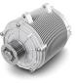

- Control Unit electric Drive (eDCU) 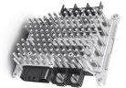
- Inductive Rotor Position Sensor (iRPS) 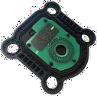

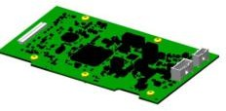
- Battery Management System (BMS)


Features
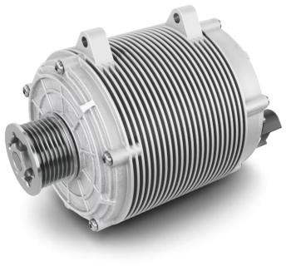


E-Motor 48 V
Electric 2/3-wheelers are reshaping urban transport and last-mile delivery. Space, weight, cost, and efficiency are key challenges for OEMs.
Schaeffler’s E-Motor 48 V delivers — a high-performance, cost optimized, efficient eMotor designed to meet the evolving needs of modern electric mobility.
Battery Electric Vehicle
Plug-in Hybrid Electric Vehicle

Mild Hybrid Electric Vehicle

GENERATE MOTION
Highlights
Scalable platform in power and torque to match diverse vehicle needs
Tailored design for electric and hybrid 2/3 wheeler applications

Robust technology featuring distributed winding for enhanced durability
Advantages
- High power density permanent magnet motor for compact yet powerful performance
- Designed to optimize magnet cost versus performance
- Low cogging torque
- Reduced phase current demand for improved energy efficiency
- Modular and scalable platform with optional reducer
integration for flexible vehicle design
Scalable output power | Up to 10 kW
Scalable output torque  at motor shaft | Up to 45 Nm
Max speed | 7,500 – 10,000 rpm
Protection class | IP67
Weight | Starting from 7.5 kg


Features
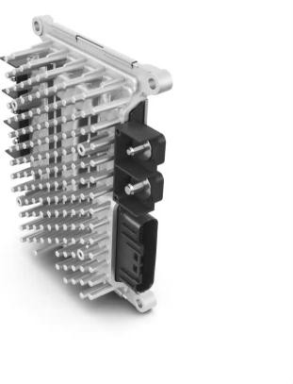



Control Unit – Electric Drive eDCU
Electric 2/3-wheelers are revolutionizing urban transport and last-mile delivery. In this fast-evolving landscape, OEMs demand solutions that are compact, efficient, and cost-effective.
Battery Electric Vehicle
Plug-in Hybrid Electric Vehicle
Schaeffler’s eDCU rises to the challenge — a smart, all-in-one
controller that merges motor and vehicle control functions into a single, scalable unit.
Mild Hybrid Electric Vehicle

GENERATE MOTION
Highlights
Scalable platform adaptable to a wide range of eMotor requirements
Tailored made for electric and hybrid 2/3 wheeler applications

Built on Schaeffler proven technology from automotive expertise
Advantages
- Seamless powertrain integration: From driver input to motor control, including vehicle-level functions
- Versatile motor control: Supports large variety of machine types
- Smart battery energy management fitting removable multi-batteries systems
- Compact & efficient: Saves space without compromising performance
- Cost effective design
Input voltage | From 39 V to 58 V
Scalable Inverter  performance | Up to 210 Arms phase current
Protection class | IP67
Functional safety | Up to ASIL-B / MSIL-C
Interface | CAN


Features

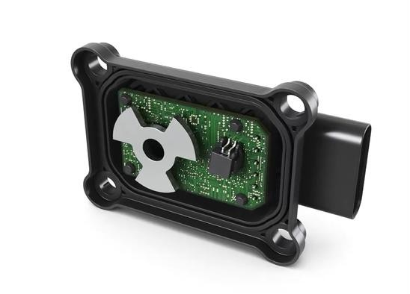

Inductive Rotor Position Sensor (iRPS) - Through Shaft
The iRPS is a compact inductive sensor dedicated to high-speed sensing. It provides accurate positioning to drive e-motors with the best efficiency.
Particularly it is integrated in e-motor applications like e-drive, brake booster, BSG (Belt Starter Generator), steering and also in aeronautics and industry.
Battery Electric Vehicle
Plug-in Hybrid Electric Vehicle
Mild Hybrid Electric Vehicle
Highlights
Magnet-free technology insensitive to low-frequency magnetic fields

Functional safety up-to ASIL- D

Active analog signal thus signal demodulation is not needed then saving at system level
Advantages
- Immune to low frequency magnetic fields
- Magnet-free technology without rare earth elements
- Light weight for sensor and target
- Configurable to any pole pair number
- Various mechanical integrations and packaging possible
Temperature | -40 °C up to 150 °C (160 °C in peak)
Supply Voltage | 5 V
Supply Current | < 20 mA
Output signal | Analog Sine / Cosine
Speed | up to 60 krpm (for 4 pairs of pole)
Accuracy | < ± 0,5° electrical
Safety | ASIL C, ASIL D capable


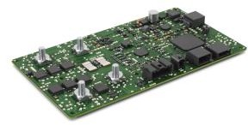


Battery Management System
Electric 2/3-wheelers are revolutionizing urban transport and last-mile delivery. In this fast-evolving landscape, demand is rising for Li-Ion batteries with compact and cost-efficient BMS solutions that meet the highest quality standards.
Battery Electric Vehicle
Plug-in Hybrid Electric Vehicle
Schaeffler’s 48V BMS rises to the challenge — a smart, all-in-one controller that merges battery management features for small to medium sized electric 2/3 wheelers.
Mild Hybrid Electric Vehicle

GENERATE MOTION
Highlights
High functionality integration

Functional safety and Cybersecurity state of the art design

Leveraging Schaeffler passenger car platforms
Advantages
- Single PCB including switching, current sensing, balancing and monitoring functions
- Compatible with internal or external BMS supply
- Scalable to different powers, cells and chemistries
- Multi-batteries compatible
- Automotive state of the art design: Focus on safety and
cell thermal management
- Cost effective solution with automotive quality standards
Features
In-series cell connection | Up to 14s (NMC) | 16s (LFP)
Continuous current | 145 A
Peak current | 210 A (30 s)
Current accuracy  absolute | relative | 0.1 A |1 % within [-300 A ; 300 A]  by shunt resistor
Circuit breaker | Mosfets
Cell balancing | 150 mA (passive)
Communication | 2 CAN modules
Safety & Security | ISO 26262 (ASIL C) & UNECE R155

